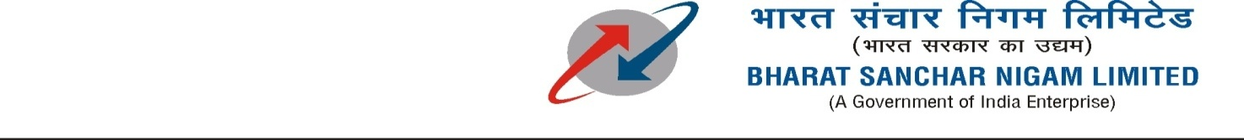
General Manager (S & M - CM)
Sales & Marketing - Consumer Mobility
3rd Floor, New CTS Building
16, Greams Road, Chennai – 600 006

S&M-CM/165/RCVs & TOPUPs/2012-13/ 103 Dated @ Chennai-6 the 15.10.12.
Sub: Full usage value equal to MRP on Top-ups with MRP Rs.110, 220,440 & 550 for 30 days –reg.
Ref: CO Circular No: 26-18/2010-T&C-CM No.53/12-13 dt 6.9.12.

With reference to the CO orders under ref., approval of the competent authority is hereby conveyed for the full usage value equal to MRP on Top-ups with MRP Rs.110, 220,440 & 550/- only in C-TOP-UP for Tamilnadu LSA (incl. CHTD) and only Rs. 110 in Paper Voucher for Tamilnadu Circle and Rs 110 & 220 in Paper Vouchers for CHTD in 2G & 3G prepaid Mobile services for 30 days from 19.10.2012 to 17.11.2012.

The details are given below:-

The promotional offer is | Full usage Value equal to MRP on top-up Voucher/C-top-up/ Flexi top-up with MRP of Rs.110, 220,440 & 550.
Period of Offer | 19.10.2012 to 17.11.2012
Applicable for | TOP-UPs of MRP Rs.110, 220,440 & 550 in C-TOP-UP/Flexi top-up & Rs.110 Paper Voucher for Tamilnadu Circle.  TOP-Ups of MRP Rs.110,220,440 & 550 in C-TOP UP/Flexi top up & Rs.110 & Rs.220 in Paper vouchers for Chennai Telecom District

Note: Wherever, the usage value offered with top-up voucher is more than the MRP, the higher usage value already offered will prevail.

This is for kind information and necessary action please.
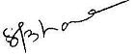
(S.BAMA)
AGM (Marketing-CM)
044-28290825, 9444979827

To
GM (NW-O CM), Trichy -1/ Coimbatore – For information & necessary action please.
GM(S&M-CM), Chennai Telephones, Chennai for information pl.
GM (F) / Sr. GM (TR) TN Circle, Chennai for information please.
DGM In charge IN - Trichy & Bangalore - for necessary action please.
DGM(NW-O)/DE Commercial, Coimbatore/ - For information & necessary action please.
Heads of SSAs, -- for kind information and necessary action please.
DGM (Sales) & AGM (Sales), Chennai-6 –For information and informing Sales Heads , franchisee managers and retail managers and other Channel partners along with commission structure as applicable.
DGM (CS), Chennai-6 - For information and informing Call Centre/Customer Service Centre Officials and ensure uploading the information on the website “tamilnadu.bsnl.co.in” .
DGM(S&M-CM)/AGM(S&M-CM), Chennai Telephones, Chennai – For information please.
DGM (ITPC) HYB – For information and ensure uploading the information on the BSNL PORTAL.

